Common Security Module
CLM Query API Detail Design

Version No: 0.1
Last Modified: 08/07/2006

Author : Vijay Parmar
Team : Common Logging Module
Client : National Cancer Institute - Center for Bioinformatics,
National Institutes of Health,
US Department of Health and Human Services

Document History

Document Location
The most current version of this document is located in CVS under security/docs/design/detail designs.

Revision History
Version Number | Revision Date | Author | Summary of Changes
.1 | 12/27/05 | Vijay Parmar | Initial version

Review
Name | Team/Role | Version | Date Reviewed | Reviewer Comments

Related Documents
More information can be found in the following related documents:

Document Name
Scope_Vision_CSM_v3.2.doc
General_Design_CSM_v3.2.doc

Table of Contents
1. Introduction 4
1.1 Definitions, Acronyms, and Abbreviations 4
2. Detail Design 4
2.1 Problem Scenario 4
2.2 Requirements 4
2.3 Assumptions 4
2.4 Dependencies 4
2.5 Proposed Solution 5
2.5.1 Query API 5
2.5.2 New/Modified Classes 5
2.5.3 New/Modified JSPs 6
2.5.4 Database 6
2.5.5 Class Diagram 7
2.5.6 Sequence Diagram 10
2.5.7 WireFrame/Mockups 10
2.5.8 XML Schema, WSDL 10
2.5.9 Configuration/Deployment Considerations 11
3. Unit Testing 11
3.1 JUnit Test Cases 11
3.2 Test Case Scenarios 11
4. Configuration/Deployment Considerations 11
4.1 Property/Configuration Files 11
4.2 Deployment Considerations 11

Query API

Introduction
This document describes the detail design Common Logging Modules Query Application Service (Query API). The Query API can be used by client application to query the log messages via a Search Criteria.

Definitions, Acronyms, and Abbreviations
All definitions, acronyms, and abbreviations are provided in the NCICB Acronyms Glossary_060905.xls document found on the shared windows directory at \\Nci6116b\6116_g1\Group\acronyms\.

Detail Design

Problem Scenario

Common Logging Module must provide the ability to query or search the generated logs via Application Service Interface. Currently, clients can use a Web based Log Locator tool to search and view generated logs. Client applications need to be able to query the logs and use the log messages for further interpretation. The Log messages can be event logs as well as Object state logs.

Requirements

Requirement ID | Requirement Description
Scope # 1 | Limit View by Organization
LOE # 2 | Retrieve objects based on Objects Primary Key and Name
LOE # 3 | Object Model – Semantic Integration.
LOE # 5 | To create a query API which accepts a query criteria object which the client application can use to populate the query parameters?  These APIs then in turn connect to the database and fire the query and return the result back to the user.  The results are returned in form of XML files (Possibly by using the XML Utility of caCORE SDK)
LOE # 6 | Log Viewer use Query API's to retrieve the results

Assumptions
N/A

Dependencies

- Hibernate 3.1.

Proposed Solution
The proposed solution mainly consists of exposing a Query interface that client applications can use to query the log messages by providing a search criteria object. The query would in turn search the log database for matching log messages and return a collection of log message to the client application.

Query API

The Query API is provided in the form of Query interface that is implemented by QueryImpl class. The Query Interface extends Constants interface. Constants interface provides required constants for query process; currently provides sortBy constants that can be specified in the SearchCriteria. SearchCriteria class allows the client application to specify search criteria required to query the log messages.
The client application instantiates and populates the SearchCriteria object and passes it to the QueryImpl. The QueryImpl invokes the LogMessageDAO interface to retrieve log messages. The LogMessageImpl returns a collection of LogMessage (EventLogMessage and ObjectStateLogMessage) objects. The collection of log messages consists of EventLogMessage and/or ObjectStateLogMessage.

New/Modified Classes

New (*) or Modified (#) | Package Name | Class/Interface | Method Name | Description
* | gov.nih.nci.logging.api.applicationservice | Constants |  | Defines constants that will be used to provide SortBy strings in SearchCriteria and other constants required for Query API.
* | gov.nih.nci.logging.api.applicationservice | Query |  | Query Interface to expose the methods available to the client.
* | gov.nih.nci.logging.api.applicationservice | QueryImpl / Query | setCriteria(SearchCriteria) | Allows the client application to specify the search criteria by passing SearchCriteria object.
* | gov.nih.nci.logging.api.applicationservice | QueryImpl / Query | query() | Method returns the search result of the query as collection. If no results are found a null collection is returned.
* | gov.nih.nci.logging.api.applicationservice | QueryImpl / Query | query(maxSize) | Method returns the search result of the query as collection of maximum size ‘maxSize’. If no results are found a null collection is returned.
* | gov.nih.nci.logging.api.applicationservice | QueryImpl / Query | query(final int currentStartOffSet, final int currentRecordCount, Collection logMessageCollection, int totalResultSize) | Query based on search criteria. This method is getting the result set to assist pagination.
* | gov.nih.nci.logging.api.applicationservice | QueryImpl / Query | toXML(collection logMessageCollection) | Returns the XML representation of the collection of LogMessage.
* | gov.nih.nci.logging.api.persistence | LogMessageDAO / LogMessageDAOImpl |  | DAO to access the logs messages
* | Gov.nih.nci.logging.api.domain | LogMessage, |  | Abstract class representing the Log Message
* | Gov.nih.nci.logging.api.domain | EventLogMessage |  | Extends LogMessage to represent Event Log Message.
* | Gov.nih.nci.logging.api.domain | ObjectStateLogMessage |  | Extends LogMessage to represent Object State Log Message.
* | Gov.nih.nci.logging.api.domain | ObjectAttributes |  | Class representing the Object Attributes of Previuos and/or current Values of the Object State Log Message.

New/Modified JSPs
N/A

Database
N/A

Class Diagram
Below is a class diagram for the Query API.
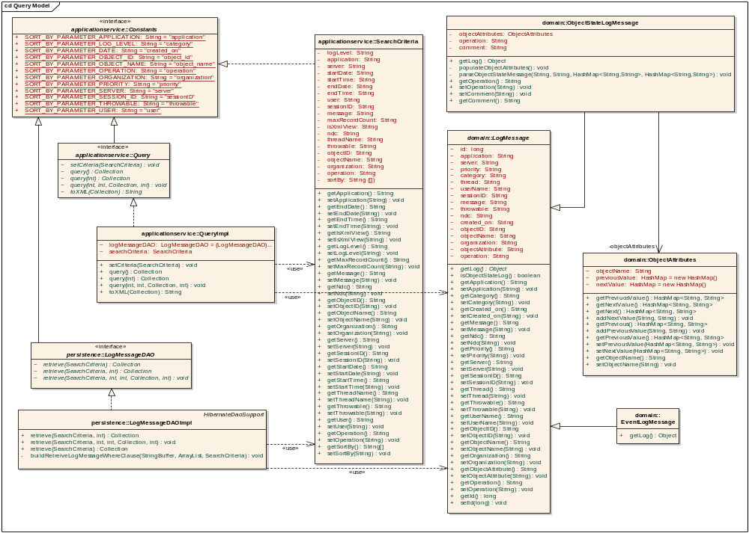
Figure 2-1 Common Logging Module Query Application Service Interface Class Diagram

Sequence Diagram
Below is a Sequence Diagram for Query API.

Query API Sequence Diagram
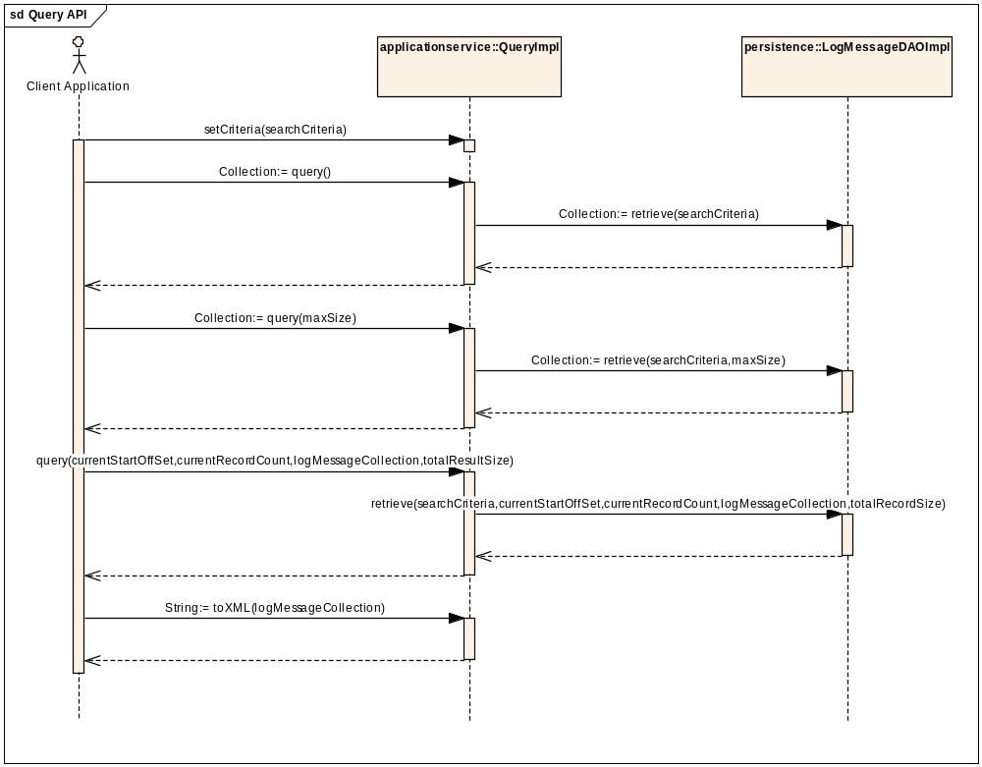
Figure 2-2 PHR Match Request Sequence Diagram

WireFrame/Mockups
N/A

XML Schema, WSDL
N/A

Configuration/Deployment Considerations

Unit Testing

JUnit Test Cases
Below are the JUnit Test Cases.

New (*) or Modified (#)
 | Package Name | Class/Interface Name | Method Name | Description
* | Test.gov.nih.nci.logging.api.applicationservice | QueryTestCase |  | Junit Class to test all public methods in the QueryImpl class
* | Test.gov.nih.nci.logging.persistence | LogMessageDAOTestCase |  | Junit Class to test all methods in the LogMessageDAOImpl class.

Test Case Scenarios

Configuration/Deployment Considerations

Property/Configuration Files
N/A

Deployment Considerations
N/A

The description should be Javadocs for the class if a new class or Javadocs for a method for method level changes.

